**A**

**Synopsis**

**on**

**TEXT TO SPEECH**

**Submitted by:**

**Group. No.**

**Anshul Yadav- 2100290140030**

**Divya Gupta- 2100290140062**

**Km Purnima- 2100290140075**



**Submitted to**

**Department of Computer Applications,**

**KIET Group of Institutions,**

**Delhi-NCR, Ghaziabad**

**Supervisor-**

**Dr. Sangeeta Arora**

**ABSTRACT**

A Text-to-speech converts text into spoken word, by analysing and processing the text using Natural Language Processing (NLP). Text-To-Speech (TTS) conversion is a computer based system that can be able to read any text aloud. It is built using Python language. We will see a simple implementation of speech to text and text to speech conversion project using two libraries:

Pyttx3 (Python text to speech version 3) and Tkinter module.

**TABLE OF CONTENTS:**

1. Introduction
2. Technologies/Software Requirements
3. Hardware requirements
4. Modules Description
5. Reports/ Outputs
6. Conclusion
7. Gantt Chart

**INTRODUCTION**

* Text to Speech (TTS) is the process of generating synthesized speech for a given text input. The output is a computer generated audio that sounds and feels like spoken by a human.
* While the field of speech synthesis is quite old, the accuracy has always been limited. Recently with introduction of neural network based approaches, there has been improvements on multiple fronts like adding languages, ascent and even making the audio seems more like human with necessary pauses and fillers!
* In Text-To-Speech conversion the input text is analysed and then this text is converted into its audio version to play. This functionality has an effective advantage when a person understands a language but is not fluent with reading and writing in that language and is also useful for the people who are visually impaired as they cannot read but understand the message by hearing it.

**TECHNOLOGIES USED**

The technologies used for developing this project is :

PYTHON

**SOFTWARE REQUIREMENTS**

The software environment used for developing the application is:

* Operating system – Windows 10/11 or Ubuntu +
* Code editor- Microsoft Visual Studio Code

**HARDWARE REQUIREMENTS**

Hardware components required for installing all the requirement and tools are:

* + Processor – Intel i3 5th generation or higher.
  + RAM- Minimum 4GB of free disk space

**MODULES IN PROJECT**

All these modules are created by the help of tkinter or pyttx3 in python. The modules present in the application are:

* Frame
* Text
* Voice Gender
* Voice Flow
* Output(Voice)
* Save voice

**GANTT CHART**

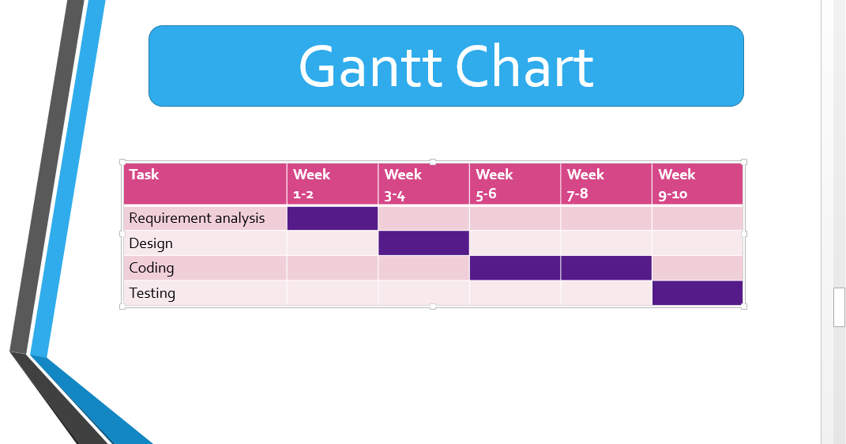

**CONCLUSION**

A text to speech is a python based GUI used Tkinter or pyttx3 modules that convert a text into voice. This system is of text to speech can be implemented for a English language only. We can actually mediate and fill the lacuna provided by not fully exploiting the capabilities of some handicapped individuals. It is never been so easy to use a text-to-speech program as you just one click and your computer will speak any text aloud in a clear natural sounding voice.